2022 Guideline for Authors (Formatting and Template)

General Guidelines for Authors (Academic Paper Sessions)
1. All submitted manuscripts should report original, unpublished research results.

2. The official language of the APMAA 2022 conference is English for both writing and presentation. If English is not your mother tongue (first language), check your draft using a professional editor and/or with a spelling and grammar matching application such as Grammarly before submitting your manuscript. You can download a free version of Grammarly on a webpage and install it on your PC. If your document is hard to read, we will decline it before sending it to our Reviewer (Desk Rejected).

3. Manuscripts should follow the structure of a traditional research paper, i.e., you will need to adjust your document to an academic format (If not, we will decline it before sending it to our Reviewer (Desk Rejected). An empirical research paper's typical organization is Title, Abstract, Introduction, Literature Review and Hypothesis Development, Method, Findings and Discussion, Conclusions, and References.

4. Use Times New Roman font with font size 12, page size A4, single-spaced.

5. The abstract should be 200-300 words on a separate page immediately preceding the text. Show five keywords below the abstract. The text should be as concise as the subject and research method permit. The text length should be over 5,000 but usually not exceed 10,000 words (If not, we will decline it before sending it to our Reviewer (Desk Rejected).

6. The cover page should contain the title of the paper, the author's name (first name, initial(s), and family name), position, and affiliation (capitalize the first character of each word). Also, contain email addresses and phone numbers. Please indicate the corresponding author.

7. To promote anonymous review, authors should not identify themselves directly or indirectly in their writing.

8. Author(s) should not use the pronoun "I" or "we." Instead, please use "this study" or "this research." Referencing should follow the APA style (http://www.apastyle.org).

9. Each author registering for the conference is limited to two (2) full-length paper submissions (including co-author papers) for the Academic Paper Sessions.

10. Authors who received a "Minor Revision" or "Major Revision" notification are expected to resubmit their revised (final) manuscripts before a specified date (the tentative deadline is August 20) to get an "Accept" notification by September 1. Our review team engages in review on a first-come-first-served basis.

11. All authors of accepted manuscripts must register, complete, and submit their camera-ready full-length papers for inclusion in the conference proceedings before the due date (Sep.15, 2022). This ensures that their manuscripts will be included in the in-house proceedings (a collection of camera-ready full-length papers). Authors, in principle, cannot make their presentations if they refuse to have their full-length papers included in the conference proceedings. Alternatively, authors can submit a short camera-ready paper whose length is no less than 5,000 words when they get permission beforehand from the Academic Paper Sessions Chair.

12. To attend and present their papers, at least one of the authors must register (pay the participation fee) for the Conference before September 15, 2022.

Template for an Academic Paper

The Margin on an A4 page
APMAA adopts the margins predefined by Microsoft Word. Authors can choose either Normal margins or Moderate margins.
Word: Normal | Top 35.01 mm, Bottom 30 mm, Left 30 mm, Right 30mm
Word: Moderate | Top mm 25.4, Bottom 25.4 mm, Left 19.05 mm, Right 19.05 mm

Cover Page
Paper Title
……………………………………………………………………………
……………………………………………………………………………

The author's name (First name, initial(s), and family name)
Position and affiliation
Affiliated University
Email address

The corresponding author's name (First name, initial(s), and family name)
Position and affiliation
Affiliated University
Email address and telephone number

Text

Paper Title
(14-point fonts; capitalize the first character of each word)

ABSTRACT: The abstract needs to provide a brief but comprehensive summary of the contents of your paper. It provides an overview of the paper and helps readers decide whether to read the full text. Visit and read Abstract and Keywords Guide, APA Style 7th Edition.
(200-300 words)

ABSTRACT: ……………………………………………………………………………
……………………………………………………………………………………………
……………………………………………………………………………………………
……………………………………………………………………………………………
……………………………………………………………………………………………
……………………………………………………………………………………………
……………………………………………………………………………………………
……………………………………………………………………………………………

Keywords: aging, attention, information processing, emotion, Japan
(5 keywords, lowercased (but capitalize proper nouns), not italic or bold)

Keywords need to be descriptive and capture the most important aspects of your paper. They are used for indexing in databases and as search terms for readers. Visit and read Abstract and Keywords Guide, APA Style 7th Edition.

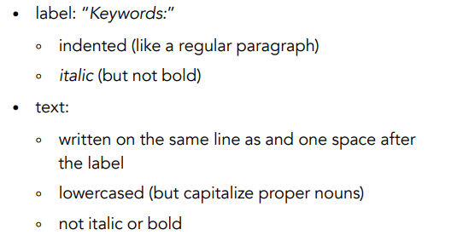

About the main body
(The text length should be over 5,000 but usually not exceed 10,000 words)
Illustrated below are the four heading levels used in the conference papers. All text paragraphs should be single-spaced, with the first line intended by 10 mm. No spaces should be placed between paragraphs. Double spacing should only be used before and after Level 1 and Level 2 headings as shown in this example. The position and style of headings should follow the example below. Please use Times New Roman font with font size 12, page size A4.

HEADING LEVEL 1

Heading Level 2
Heading Level 3
Heading Level 4.

1. INTRODUCTION
(Background of the study and an overview of related work in the area of the research; the problem domain; the specific problem addressed, research questions, research objectives, and expected research outcome.)

xxx……………………………………………………………………………………
……………………………………………………………………………………………
……………………………………………………………………………………………
……………………………………………………………………………………………
xxx……………………………………………………………………………………
……………………………………………………………………………………………
……………………………………………………………………………………………
……………………………………………………………………………………………
……………………………………………………………………………………………

2. LITERATURE REVIEW AND HYPOTHESIS DEVELOPMENT
(The original fundamental concepts; related literature; hypothesis/proposition of the thesis; conceptual framework of the study.)

xxx……………………………………………………………………………………
……………………………………………………………………………………………

Heading Level 2

xxx……………………………………………………………………………………
……………………………………………………………………………………………
……………………………………………………………………………………………
……………………………………………………………………………………………
Heading Level 3
xxx……………………………………………………………………………………
…………………………………………………………………………………………………………………………………………………………………………………………
……………………………………………………………………………………………

2. METHOD
(Methodological approach, e.g., population, sample, measurements, data collection method, and data analysis.)

xxx…………………………………………………………………………………………………………………………………………………………………………………

Heading Level 2

xxx…………………………………………………………………………………………………………………………………………………………………………………
……………………………………………………………………………………………
……………………………………………………………………………………………

Figure 1: (If any)
Table 1: (if any)
Sample Annotated Professional Paper in APA Style
Heading Level 3
xxx……………………………………………………………………………………
……………………………………………………………………………………………
……………………………………………………………………………………………
……………………………………………………………………………………………
Heading Level 4
xxx……………………………………………………………………………………
……………………………………………………………………………………………
……………………………………………………………………………………………
……………………………………………………………………………………………

3. FINDINGS AND DISCUSSION
(Results; discussion with previous studies.)

xxx…………………………………………………………………………………………………………………………………………………………………………………
……………………………………………………………………………………………

Heading Level 2

xxx…………………………………………………………………………………………………………………………………………………………………………………
……………………………………………………………………………………………
……………………………………………………………………………………………
Heading Level 3 xxx……………………………………………………………………………………
……………………………………………………………………………………………
……………………………………………………………………………………………

4, CONCLUSIONS
(Conclusion; expected contributions; recommendation; future studies; the research progress.)

xxx……………………………………………………………………………………
……………………………………………………………………………………………
……………………………………………………………………………………………
……………………………………………………………………………………………

REFERENCES

References are ordered alphabetically by the first author's last name. If the author is unknown, order the reference entry by the first meaningful word of the title (ignoring articles: "the," "a," or "an").
(Follow acceptable citation styles, American Psychological Association or APA Style. The following example uses double spaced lines, however for APMAA 2022, you need to use single-spaced lines)

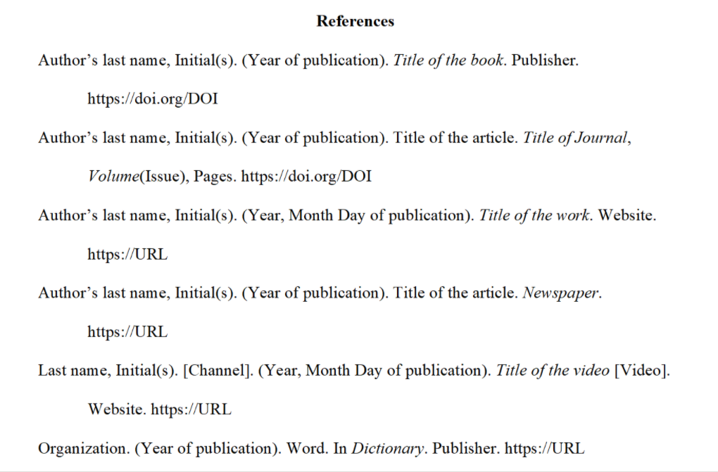

……………………………………………………………………………………………
……………………………………………………………………………………………
……………………………………………………………………………………………

General Guidelines for Authors (Doctoral Colloquium)

Doctoral students and candidates at all stages are welcome to submit a thesis-position paper, but preference will be given to students in the earlier stages of their doctoral work. Doctoral students interested in participating in the Doctoral Colloquium should submit a single file (in both PDF and Word) consisting of:
-An introductory letter in which you indicate what you wish to obtain from the Doctoral Colloquium and what you will be bringing to the Doctoral Colloquium.
-A one-page research statement in the research field you will pursue. This statement should focus on the dissertation if you are at the doctoral dissertation stage.
-Your CV.
-A letter of recommendation from your primary dissertation advisor should state what you could contribute and gain from the doctoral consortium.
-Your research paper
The submitted paper should clearly state:
An overview of related work in the area of the doctoral work
The original fundamental idea/research questions/hypothesis of the thesis
The problem domain and the specific problem addressed
Methodological approach
The expected contributions
Research carried out

Notification
Please be notified that
-The first author should be a doctoral student responsible for researching the topic. If the supervisor becomes a co-author, he or she should be a second or subsequent author.-

-The official language is English in both writing and presentation. If English is not your mother tongue (first language), check your draft by employing a professional editor and/or with a spelling and grammar matching application such as Grammarly before submitting your manuscript. You can download a free version on a webpage and install it on your PC. If your document is hard to read, we will decline it before sending it to our Reviewer (Mentor).
-The abstract should be 200-300 words on a separate page immediately preceding the text. Show five keywords below the abstract. The text should be as concise as the subject and research method permits. The text length should be about 4,000- 8,000 words. (If not, Desk Rejected). Use Times New Roman font with font size 12, page size A4, single-spaced.

-The colloquium chairs will arrange the selection of the accepted papers using a peer-review process.

-Accepted manuscripts whose first author (doctoral student) will have completed registration and submission of the camera-ready full-length paper before the due date (Sep.15, 2022) will be included in the in-house proceedings (a collection of camera-ready full-length papers). Authors (students), in principle, cannot make their presentations if they refuse to have their full-length papers included in the conference proceedings. Alternatively, authors can submit a short camera-ready paper whose length is no less than 4,000 words when he/she gets a permission beforehand from the Doctoral Colloquium Chair.

Template for a Doctoral Colloquium Paper

Paper Title (Cover Page)
……………………………………………………………………………………………
……………………………………………………………………………………………

Name-Surname of Doctoral Student (First Author)
Studying University, Country
Course/Program
Email address and telephone number

Name-Surname of Thesis Supervisor(s)
Affiliated University, Country
Email address

Date

ABSTRACT: The abstract needs to provide a brief but comprehensive summary of the contents of your paper. It provides an overview of the paper and helps readers decide whether to read the full text. Visit and read Abstract and Keywords Guide, APA Style 7th Edition.
(200-300 words)

ABSTRACT: ……………………………………………………………………………
……………………………………………………………………………………………
……………………………………………………………………………………………
……………………………………………………………………………………………

Keywords: aging, attention, information processing, emotion, visual search
(5 keywords, lowercased (but capitalize proper nouns), not italic or bold)

Keywords need to be descriptive and capture the most important aspects of your paper. They are used for indexing in databases and as search terms for readers. Visit and read
Abstract and Keywords Guide, APA Style 7th Edition.

About main body (Overall text length should be about 4,000- 8,000 words.)

Illustrated below are the four heading levels used in the conference papers. All text paragraphs should be single-spaced, with the first line intended by 10 mm. No spaces should be placed between paragraphs. Double spacing should only be used before and after Level 1 and Level 2 headings as shown in this example. The position and style of headings should follow the example below.
Please use Times New Roman font with Font size 12, page size A4.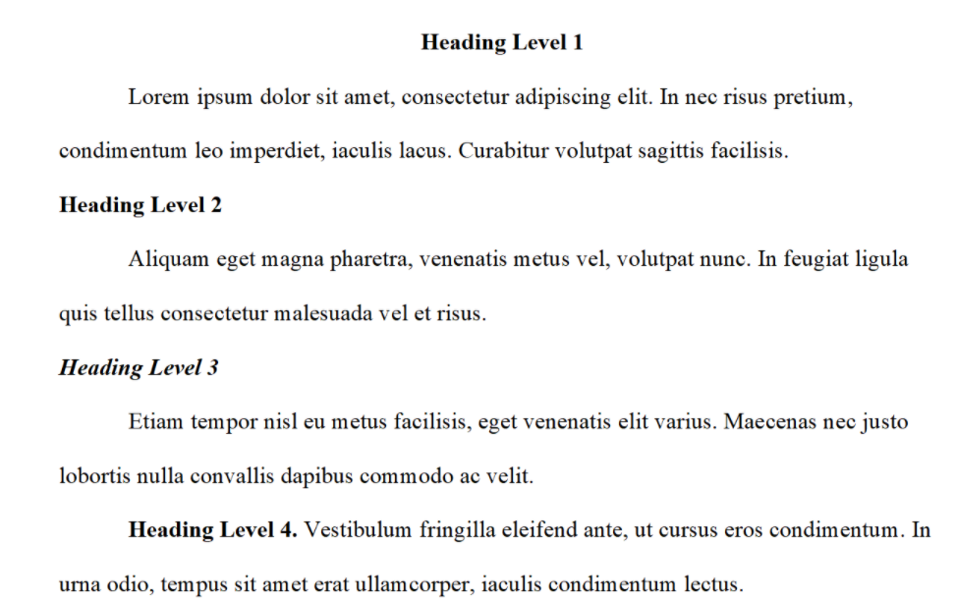

1. INTRODUCTION

(Background information and an overview of related work in the area of the doctoral work; the problem domain; the specific problem addressed, research questions, and research objectives.)

xxx……………………………………………………………………………………
……………………………………………………………………………………………
……………………………………………………………………………………………

Heading Level 2

xxx……………………………………………………………………………………
……………………………………………………………………………………………
……………………………………………………………………………………………
……………………………………………………………………………………………
……………………………………………………………………………………………
Heading Level 3
xxx……………………………………………………………………………………
……………………………………………………………………………………………
……………………………………………………………………………………………
……………………………………………………………………………………………
……………………………………………………………………………………………

- LITERATURE REVIEW AND HYPOTHESIS DEVELOPMENT

(The original fundamental concepts; related literature; hypothesis/proposition of the thesis; conceptual framework of the study.)

xxx……………………………………………………………………………………
……………………………………………………………………………………………
……………………………………………………………………………………………

Heading Level 2

xxx……………………………………………………………………………………
……………………………………………………………………………………………
……………………………………………………………………………………………
……………………………………………………………………………………………
……………………………………………………………………………………………
Heading Level 3
xxx……………………………………………………………………………………
……………………………………………………………………………………………
……………………………………………………………………………………………
……………………………………………………………………………………………
……………………………………………………………………………………………

- METHOD

(Methodological approach, e.g., population, sample, measurements, data collection method, and data analysis.)

xxx……………………………………………………………………………………
……………………………………………………………………………………………
……………………………………………………………………………………………

Heading Level 2

xxx……………………………………………………………………………………
……………………………………………………………………………………………
……………………………………………………………………………………………
……………………………………………………………………………………………
……………………………………………………………………………………………

Figure 1: (If any)
Table 1: (if any)
Sample Annotated Professional Paper in APA Style
Heading Level 3
xxx……………………………………………………………………………………
……………………………………………………………………………………………

- FINDINGS AND DISCUSSION
(Results; discussion with previous studies.)

xxx……………………………………………………………………………………
……………………………………………………………………………………………
……………………………………………………………………………………………

Heading Level 2

xxx……………………………………………………………………………………
……………………………………………………………………………………………
……………………………………………………………………………………………
……………………………………………………………………………………………
……………………………………………………………………………………………
Heading Level 3
xxx……………………………………………………………………………………
……………………………………………………………………………………………
……………………………………………………………………………………………
……………………………………………………………………………………………
……………………………………………………………………………………………

- CONCLUSIONS
(Conclusion; expected contributions; recommendation; future studies; the research progress.)

xxx……………………………………………………………………………………
……………………………………………………………………………………………
……………………………………………………………………………………………
……………………………………………………………………………………………

REFERENCES
(Follow acceptable citation styles, American Psychological Association or APA Style, but use a Single Space).

References are ordered alphabetically by the first author's last name. If the author is unknown, order the reference entry by the first meaningful word of the title (ignoring articles: "the", "a", or "an").

How to submit your documents to the Doctoral Colloquium Track of the 2022 CMT site

APMAA 2022 employs the Conference Management Toolkit (CMT) that Microsoft Corporation provides to manage submitted papers. Before submitting your documents, please register your ID and Password in the CMT system. If you have a CMT account, there is no need to make a new account. You can log in to CMT with that account.
In your Author console, please select the "Doctoral Colloquium" track, and move to the "Create New Submission" page. Please fill the page, and select the "Doctoral students" at SUBJECT AREAS. And submit your files. Please ensure your submission meets this "2022 Guideline for Authors (Formatting and Template)." We will open the CMT submission site on May 20, 2022. The Paper Submission Deadline is July 15.

